DE LA TORRE Ignacio  Date of birth February 1st 1974  Nationality Spanish  Forwarding address Email: ignacio.de.la.torre@alumni.insead.edu  Eduardo Dato 13, 6º B  28010 Madrid Tel. + 34 670 374 267 Work + 34 914 369 613 | 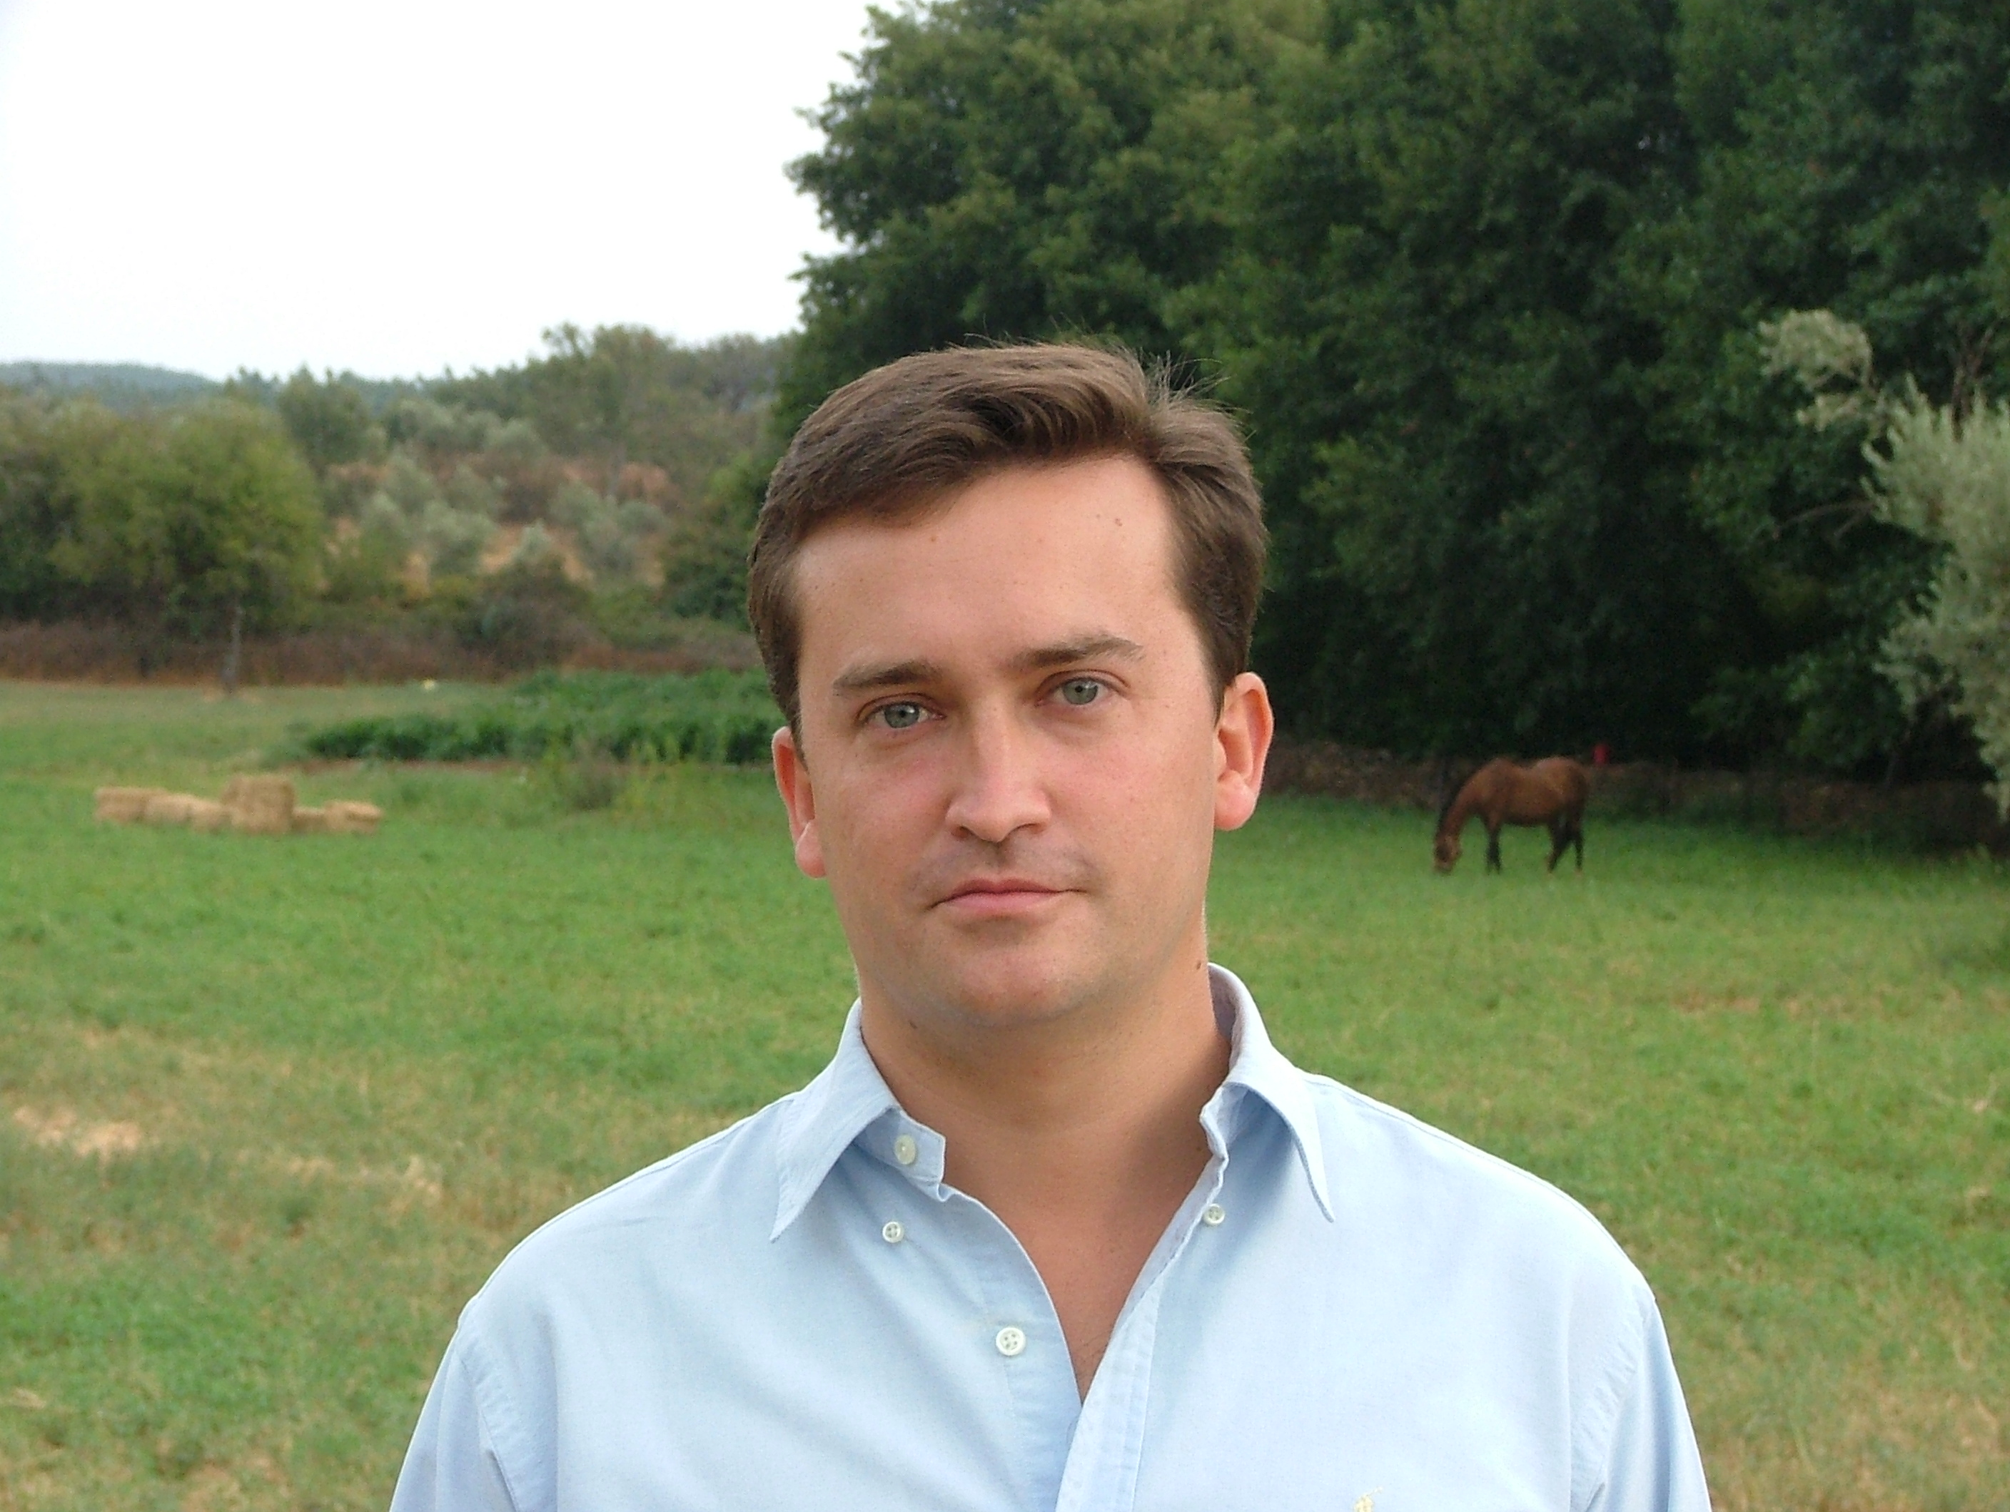
WORK EXPERIENCE

2001 - 2007 UBS Investment Bank / UBS WARBURG – Executive Director
Sold European Equities & Derivatives into Spanish Institutions Madrid, Spain
- Account Manager of BBVA, Banco Popular, Barclays España, Bankpyme, Fonditel, Barclays, ESAF, Omega Capital and Mutuactivos. Co-coverage of Santander, Caixagest, Invercaixa & DWS. Ranked between the best 80 pan-euro sales in Europe (Extel 2003).
Equity Research / Media Specialist Sales/ Madrid, Spain
- Sold Global Media Equities into Spanish and Portuguese investors. Ranked #1 by BBVA, #1-3 by BSCH, #3 by Sabadell, #4 by Caixagest. Ranked as media specialist sales (Extel 2002 survey).
- Equity Research. Coverage of Iberian Media, tobacco and non-food retail stocks. Ranked in the Institutional Investor Autumn 2001 as Media & Spanish analyst. Originated road-shows with the CEO of Prisa and the Chairman of Recoletos.
DEUTSCHE BANK Madrid, Spain
1998 - 2000 Equity Research – Mid cap Analyst. Conducted in-depth company analysis, valuations, recommendations and marketing. Responsible for the following sectors: technology, tobacco & food, and utilities. Achievements: € 2 m. generated in primary & secondary commissions during 1999. Lead analyst in the IPO of Indra, Amadeus I & Brisa III
- Ranked: 4th Best Electronics analyst in Europe (Reuters 2000, Small Caps, voted by CFOs), 7th Best Tobacco analyst in Europe (Reuters 2000 Large Caps, voted by Fund Managers), and 6th Best Utilities analyst in Europe (Reuters 2000, Small Caps, voted by CFOs).
1997 - 1998 Corporate Finance Analyst. M&A origination and execution, ECM (IPOs & Block Trades) origination within Deutsche’s Spanish team. Wrote 5 information memorandums. Identified potential buyers and sellers in M&A transactions. Managed data rooms. Achievements: Sold four companies (Bertako, San Andrés, Videcart, Papelera Catalana). Bought one company in Argentina. Member of the team who originated the IPO of Azkar.
1999 - 2007 www.tododvd.com: Founding Partner & Member of the Board Madrid, Spain
Launching of Fénix Network S. L: Internet project during 1999, implementation of business plan, first steps, team recruiting. Searched for investors & negotiated its entry.
TEACHING INSTITUTO DE EMPRESA BUSINESS SCHOOL (IE)
Academic Director of the Master in Financial Management and Executive Master in Dirección Financiera, 2007 to present.
Associate Professor of finance, equity valuation, financial accounting & creative accounting. Ranked best Professor of the Master in Financial Management, 2006. Author of the case: "Xfera: What’s A Fair Price?: Spain’s 4th UMTS license", published during 2003, awarded as the best case of the year 2002-2003 by IE’s dean. One of the 5 world-wide cases accepted in the final of the North American Case Research Association (Finance & Economics participants -Autumn 2003).

INSEAD: Author of the case "solodvd.com, an online retailer of DVD hardware and software in Spain" (Published by INSEAD during 2002 & used in Fontainebleau & Singapore). Published as well its Case B: “solodvd.com, key success factor for turning around failed start-ups” for INSEAD-Singapore (Entrepreneurship Department).

EDUCATION

1998 - 2003 Universidad Nacional de Educación a Distancia (UNED) Spain, France, UK
Ph. D. (suma cum laude) in Medieval History. Dissertation: Financial Activities of the Templar Knights
2000 - 2001 INSEAD Fontainebleau, France / Singapore
MBA Programme. BROADVIEW SCHOLARSHIP (Technology-oriented career)
1992 - 1997 ICADE (Universidad Pontificia Comillas) Madrid, Spain
M. Sc. in Economics & Business Administration. Major: Finance
1993 - 1997 Universidad Nacional de Educación a Distancia (UNED) Madrid, Spain
MA in Law. Member of the Madrid College of Lawyers.

PUBLICATIONS Los Templarios y el origen de la Banca. Editorial Dilema, 2004.
Ingeniería Financiera. Ed. Lid, 2006.
Islamismo: Raíces y explosión. Editorial Lid y Editorial Dilema, 2005. Prólogo Jorge Dezcallar.
«Contabilidad creativa de entidades públicas», Observatorio Contable, Febrero 2007.
«En qué cree el Presidente de Irán», Expansión, 5 de Enero de 2006.
«Los orígenes de Hizbullah», Expansión, 19 de Agosto de 2006.
«Quién es quién en Irak», Expansión, 22 de Marzo de 2006.
«Xfera: What’s A Fair Price?», (coautor), Instituto de Empresa. Premiado como mejor caso publicado por el IE durante 2002-2003.

«solodvd.com, an online retailer of DVD hardware and software in Spain», INSEAD, 2002.

«Key success factors in turning around failed start-ups», INSEAD, 2003.
«Los orígenes del Ku Klux Klan», La Aventura de la Historia, 2006.
«El Temple como casa de banca. Consideraciones historiográficas y bibliográficas», Espacio, Tiempo y Forma, UNED, 2004.
«Evolución del derecho cambiario bajomedieval. Aportación Templaria», Espacio, Tiempo y Forma, UNED, 2005 (en publicación).
«La caída del Temple», Espacio, Historia Medieval, Mayo, 2005.
«The Templars as Papal Bankers», II Congreso Historia de las Cruzadas, Society for the Study of the Crusades & the Latin East, Estambul, 2004.

«El uso de Internet para el investigador de Historia Medieval», IX Encuentro de la Asociación Iberoamericana de Educación Superior a Distancia, Cartagena de Indias, 2001.
«Cómo valorar empresas de Internet», E-comm, Junio 2000.
OTHER Languages: Spanish -native-, English (very fluent), French (average), German (basic)
ALLIANZ (AGF International). Internship in the marketing division Paris, France
Exchange student Cameroon / USA / France / Austria / UK
Member of the board of INSEAD alumni in Spain.
Nominated to Prize Rey Jaime I in Economics 2005 by Nobel Prize, Prof. Sir Aaron Klug.

Interests: Spanish guitar. Enjoy opera, literature, fencing, history, technology, golf, travel.

